**Predict passengers**

library(readxl)

airlines<-read_excel(file.choose())

airlines1<-airlines

plot(airlines,type="o")

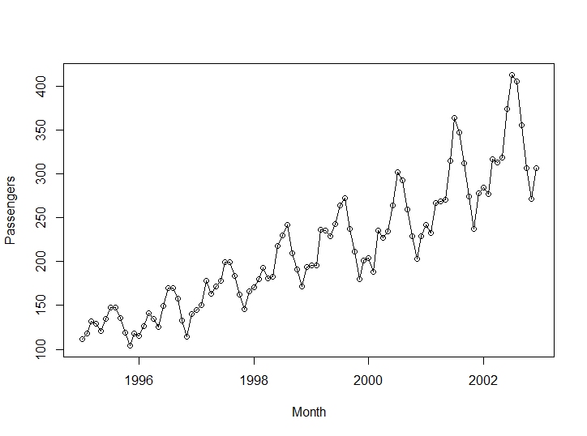

airlines1<-data.frame(airlines,month.abb)

library(dummies)

a<-dummy(airlines1$month.abb)

Warning message:

In model.matrix.default(~x - 1, model.frame(~x - 1), contrasts = FALSE) :

non-list contrasts argument ignored

airlines1<-data.frame(airlines1,a)

#install.packages("tseries")

#install.packages("forecast")

t<-list(1:96)

airlines1<-data.frame(airlines1,t)

sqt<-t^2

Error in t^2 : non-numeric argument to binary operator

sqt<-(airlines1$X1.96)^2

airlines1<-data.frame(airlines1,sqt)

logt<-log(airlines1$X1.96)

airlines1<-data.frame(airlines1,logt)

airlines1["logpassengers"]<-log(airlines1$Passengers)

attach(airlines1)

airlines_train<-airlines1[1:84,]

airlines_test<-airlines1[85:96,]

>

>

>

>

LinearModel<-lm(Passengers~X1.96,data = airlines_train)

summary(LinearModel)

Call:

lm(formula = Passengers ~ X1.96, data = airlines_train)

Residuals:

Min 1Q Median 3Q Max

-55.419 -17.202 -0.705 16.546 88.438

Coefficients:

Estimate Std. Error t value Pr(>|t|)

(Intercept) 106.2708 5.9287 17.93 <2e-16 ***

X1.96 2.1429 0.1212 17.69 <2e-16 ***

---

Signif. codes: 0 ‘***’ 0.001 ‘**’ 0.01 ‘*’ 0.05 ‘.’ 0.1 ‘ ’ 1

Residual standard error: 26.93 on 82 degrees of freedom

Multiple R-squared: 0.7923, Adjusted R-squared: 0.7898

F-statistic: 312.8 on 1 and 82 DF, p-value: < 2.2e-16

pred_linear<-predict(LinearModel,interval = "predict",newdata =airlines_test)

rmse_lm<-sqrt(mean((pred_linear-airlines_test$Passengers)^2))

rmse_lm

[1] 69.68097

>

exponential_model<-lm(logpassengers~X1.96,data = airlines_train)

summary(exponential_model)

Call:

lm(formula = logpassengers ~ X1.96, data = airlines_train)

Residuals:

Min 1Q Median 3Q Max

-0.28906 -0.07775 -0.01528 0.07901 0.25104

Coefficients:

Estimate Std. Error t value Pr(>|t|)

(Intercept) 4.770262 0.027693 172.26 <2e-16 ***

X1.96 0.011087 0.000566 19.59 <2e-16 ***

---

Signif. codes: 0 ‘***’ 0.001 ‘**’ 0.01 ‘*’ 0.05 ‘.’ 0.1 ‘ ’ 1

Residual standard error: 0.1258 on 82 degrees of freedom

Multiple R-squared: 0.8239, Adjusted R-squared: 0.8218

F-statistic: 383.7 on 1 and 82 DF, p-value: < 2.2e-16

pred_additive<-predict(exponential_model,airlines_test)

pred_additive

85 86 87 88 89 90 91 92 93 94 95 96

5.712637 5.723724 5.734811 5.745897 5.756984 5.768071 5.779158 5.790245 5.801331 5.812418 5.823505 5.834592

pred_additive<-exp(pred_additive)

rmse_lm_add<-sqrt(mean((pred_additive-airlines_test$Passengers)^2))

rmse_lm_add

[1] 46.05736

>

quadratic_model<-lm(Passengers~X1.96+sqt,data = airlines_train)

summary(quadratic_model)

Call:

lm(formula = Passengers ~ X1.96 + sqt, data = airlines_train)

Residuals:

Min 1Q Median 3Q Max

-56.985 -15.652 -3.801 16.360 83.241

Coefficients:

Estimate Std. Error t value Pr(>|t|)

(Intercept) 1.148e+02 8.996e+00 12.758 < 2e-16 ***

X1.96 1.549e+00 4.885e-01 3.172 0.00214 **

sqt 6.982e-03 5.569e-03 1.254 0.21350

---

Signif. codes: 0 ‘***’ 0.001 ‘**’ 0.01 ‘*’ 0.05 ‘.’ 0.1 ‘ ’ 1

Residual standard error: 26.83 on 81 degrees of freedom

Multiple R-squared: 0.7963, Adjusted R-squared: 0.7912

F-statistic: 158.3 on 2 and 81 DF, p-value: < 2.2e-16

pred_linear<-predict(quadratic_model,interval = "predict",newdata =airlines_test)

rmse_lm<-sqrt(mean((pred_linear-airlines_test$Passengers)^2))

rmse_lm

[1] 67.63403

>

Additive_model<-lm(Passengers~month.abbApr+month.abbAug+month.abbFeb+month.abbJan+month.abbJul+month.abbJun+month.abbMar+month.abbMay+month.abbNov+month.abbOct+month.abbSep,data = airlines_train)

summary(Additive_model)

Call:

lm(formula = Passengers ~ month.abbApr + month.abbAug + month.abbFeb +

month.abbJan + month.abbJul + month.abbJun + month.abbMar +

month.abbMay + month.abbNov + month.abbOct + month.abbSep,

data = airlines_train)

Residuals:

Min 1Q Median 3Q Max

-91.571 -51.393 2.143 38.464 124.429

Coefficients:

Estimate Std. Error t value Pr(>|t|)

(Intercept) 189.429 21.746 8.711 7.21e-13 ***

month.abbApr 1.857 30.753 0.060 0.952

month.abbAug 49.286 30.753 1.603 0.113

month.abbFeb -19.286 30.753 -0.627 0.533

month.abbJan -20.143 30.753 -0.655 0.515

month.abbJul 50.143 30.753 1.630 0.107

month.abbJun 25.143 30.753 0.818 0.416

month.abbMar 8.000 30.753 0.260 0.796

month.abbMay 1.143 30.753 0.037 0.970

month.abbNov -24.286 30.753 -0.790 0.432

month.abbOct -1.000 30.753 -0.033 0.974

month.abbSep 24.143 30.753 0.785 0.435

---

Signif. codes: 0 ‘***’ 0.001 ‘**’ 0.01 ‘*’ 0.05 ‘.’ 0.1 ‘ ’ 1

Residual standard error: 57.53 on 72 degrees of freedom

Multiple R-squared: 0.1674, Adjusted R-squared: 0.04015

F-statistic: 1.316 on 11 and 72 DF, p-value: 0.2337

pred_additive<-predict(Additive_model,airlines_test)

pred_additive

85 86 87 88 89 90 91 92 93 94 95 96

169.2857 170.1429 197.4286 191.2857 190.5714 214.5714 239.5714 238.7143 213.5714 188.4286 165.1429 189.4286

rmse_lm_add<-sqrt(mean((pred_additive-airlines_test$Passengers)^2))

rmse_lm_add

[1] 132.8198

>

Multiplicative_model<-lm(logpassengers~month.abbApr+month.abbAug+month.abbFeb+month.abbJan+month.abbJul+month.abbJun+month.abbMar+month.abbMay+month.abbNov+month.abbOct+month.abbSep,data = airlines_train)

summary(Multiplicative_model)

Call:

lm(formula = logpassengers ~ month.abbApr + month.abbAug + month.abbFeb +

month.abbJan + month.abbJul + month.abbJun + month.abbMar +

month.abbMay + month.abbNov + month.abbOct + month.abbSep,

data = airlines_train)

Residuals:

Min 1Q Median 3Q Max

-0.43858 -0.28085 0.04875 0.22435 0.46174

Coefficients:

Estimate Std. Error t value Pr(>|t|)

(Intercept) 5.208117 0.111153 46.856 <2e-16 ***

month.abbApr 0.011394 0.157194 0.072 0.942

month.abbAug 0.227676 0.157194 1.448 0.152

month.abbFeb -0.097238 0.157194 -0.619 0.538

month.abbJan -0.112831 0.157194 -0.718 0.475

month.abbJul 0.227301 0.157194 1.446 0.153

month.abbJun 0.120037 0.157194 0.764 0.448

month.abbMar 0.047126 0.157194 0.300 0.765

month.abbMay 0.001676 0.157194 0.011 0.992

month.abbNov -0.138701 0.157194 -0.882 0.381

month.abbOct -0.006967 0.157194 -0.044 0.965

month.abbSep 0.120513 0.157194 0.767 0.446

---

Signif. codes: 0 ‘***’ 0.001 ‘**’ 0.01 ‘*’ 0.05 ‘.’ 0.1 ‘ ’ 1

Residual standard error: 0.2941 on 72 degrees of freedom

Multiple R-squared: 0.1548, Adjusted R-squared: 0.02568

F-statistic: 1.199 on 11 and 72 DF, p-value: 0.3036

pred_additive<-predict(Multiplicative_model,airlines_test)

pred_additive

85 86 87 88 89 90 91 92 93 94 95 96

5.095286 5.110879 5.255243 5.219512 5.209793 5.328155 5.435418 5.435793 5.328630 5.201150 5.069416 5.208117

pred_additive<-exp(pred_additive)

rmse_lm_add<-sqrt(mean((pred_additive-airlines_test$Passengers)^2))

rmse_lm_add

[1] 140.0632

>

quadra_additive_model<-lm(Passengers~month.abbApr+month.abbAug+month.abbFeb+month.abbJan+month.abbJul+month.abbJun+month.abbMar+month.abbMay+month.abbNov+month.abbOct+month.abbSep+X1.96+sqt,data = airlines_train)

summary(quadra_additive_model)

Call:

lm(formula = Passengers ~ month.abbApr + month.abbAug + month.abbFeb +

month.abbJan + month.abbJul + month.abbJun + month.abbMar +

month.abbMay + month.abbNov + month.abbOct + month.abbSep +

X1.96 + sqt, data = airlines_train)

Residuals:

Min 1Q Median 3Q Max

-32.297 -7.694 0.392 7.735 40.922

Coefficients:

Estimate Std. Error t value Pr(>|t|)

(Intercept) 95.003657 6.438877 14.755 < 2e-16 ***

month.abbApr 19.310867 6.865106 2.813 0.006367 **

month.abbAug 58.135165 6.853340 8.483 2.36e-12 ***

month.abbFeb 2.378205 6.873752 0.346 0.730393

month.abbJan 3.603175 6.878882 0.524 0.602071

month.abbJul 61.166361 6.855628 8.922 3.67e-13 ***

month.abbJun 38.325091 6.858349 5.588 4.11e-07 ***

month.abbMar 27.566483 6.869176 4.013 0.000148 ***

month.abbMay 16.468498 6.861505 2.400 0.019052 *

month.abbNov -22.050366 6.849272 -3.219 0.001949 **

month.abbOct 3.455372 6.850131 0.504 0.615547

month.abbSep 30.802930 6.851500 4.496 2.68e-05 ***

X1.96 1.507479 0.233462 6.457 1.20e-08 ***

sqt 0.007662 0.002660 2.881 0.005263 **

---

Signif. codes: 0 ‘***’ 0.001 ‘**’ 0.01 ‘*’ 0.05 ‘.’ 0.1 ‘ ’ 1

Residual standard error: 12.81 on 70 degrees of freedom

Multiple R-squared: 0.9598, Adjusted R-squared: 0.9524

F-statistic: 128.7 on 13 and 70 DF, p-value: < 2.2e-16

pred_additive<-predict(quadra_additive_model,airlines_test)

pred_additive

85 86 87 88 89 90 91 92 93 94 95 96

282.0989 283.6916 311.7128 306.3055 306.3267 331.0623 356.7978 356.6762 332.2689 307.8615 285.3113 310.3326

rmse_lm_add<-sqrt(mean((pred_additive-airlines_test$Passengers)^2))

rmse_lm_add

[1] 26.36082

>

final_model<-lm(Passengers~month.abbApr+month.abbAug+month.abbFeb+month.abbJan+month.abbJul+month.abbJun+month.abbMar+month.abbMay+month.abbNov+month.abbOct+month.abbSep+X1.96+sqt,data = airlines1)

summary(final_model)

Call:

lm(formula = Passengers ~ month.abbApr + month.abbAug + month.abbFeb +

month.abbJan + month.abbJul + month.abbJun + month.abbMar +

month.abbMay + month.abbNov + month.abbOct + month.abbSep +

X1.96 + sqt, data = airlines1)

Residuals:

Min 1Q Median 3Q Max

-30.978 -10.111 -0.145 8.304 41.123

Coefficients:

Estimate Std. Error t value Pr(>|t|)

(Intercept) 95.096544 6.833399 13.916 < 2e-16 ***

month.abbApr 21.560046 7.308113 2.950 0.00414 **

month.abbAug 65.212910 7.298541 8.935 9.69e-14 ***

month.abbFeb 3.096448 7.315181 0.423 0.67319

month.abbJan 5.455357 7.319357 0.745 0.45820

month.abbJul 69.333986 7.300387 9.497 7.39e-15 ***

month.abbJun 44.932200 7.302596 6.153 2.66e-08 ***

month.abbMar 29.714677 7.311442 4.064 0.00011 ***

month.abbMay 19.257553 7.305169 2.636 0.01003 *

month.abbNov -23.162481 7.295306 -3.175 0.00211 **

month.abbOct 4.027177 7.295981 0.552 0.58247

month.abbSep 34.568974 7.297067 4.737 8.97e-06 ***

X1.96 1.239459 0.217218 5.706 1.78e-07 ***

sqt 0.011430 0.002169 5.271 1.08e-06 ***

---

Signif. codes: 0 ‘***’ 0.001 ‘**’ 0.01 ‘*’ 0.05 ‘.’ 0.1 ‘ ’ 1

Residual standard error: 14.59 on 82 degrees of freedom

Multiple R-squared: 0.9645, Adjusted R-squared: 0.9588

F-statistic: 171.2 on 13 and 82 DF, p-value: < 2.2e-16

fitted.values(final_model)

1 2 3 4 5 6 7 8 9 10 11 12 13 14 15

101.8028 100.7176 128.6325 121.7973 120.8372 147.8770 173.6668 170.9567 141.7465 112.6614 86.9512 111.6160 118.5966 117.7858 145.9750

16 17 18 19 20 21 22 23 24 25 26 27 28 29 30

139.4141 138.7283 166.0425 192.1066 189.6708 160.7350 131.9242 106.4883 131.4275 138.6824 138.1459 166.6094 160.3229 159.9114 187.4999

31 32 33 34 35 36 37 38 39 40 41 42 43 44 45

213.8384 211.6769 183.0154 154.4789 129.3174 154.5309 162.0602 161.7980 190.5359 184.5237 184.3865 212.2494 238.8622 236.9750 208.5879

46 47 48 49 50 51 52 53 54 55 56 57 58 59 60

180.3257 155.4385 180.9264 188.7299 188.7421 217.7543 212.0164 212.1536 240.2908 267.1779 265.5651 237.4523 209.4644 184.8516 210.6138

61 62 63 64 65 66 67 68 69 70 71 72 73 74 75

218.6917 218.9782 248.2647 242.8012 243.2126 271.6241 298.7856 297.4471 269.6086 241.8951 217.5566 243.5931 251.9454 252.5062 282.0670

76 77 78 79 80 81 82 83 84 85 86 87 88 89 90

276.8778 277.5637 306.2495 333.6853 332.6212 305.0570 277.6178 253.5536 279.8645 288.4910 289.3262 319.1614 314.2465 315.2067 344.1668

91 92 93 94 95 96

371.8770 371.0872 343.7973 316.6325 292.8426 319.4278

>

write.csv(airlines1, file="airlinesTest.csv")

>

test<-read.csv(file.choose())

test["pred_passenger"]<-predict(final_model,test)

>

errors<-final_model$residuals

acf(errors,lag.max = 50)

>

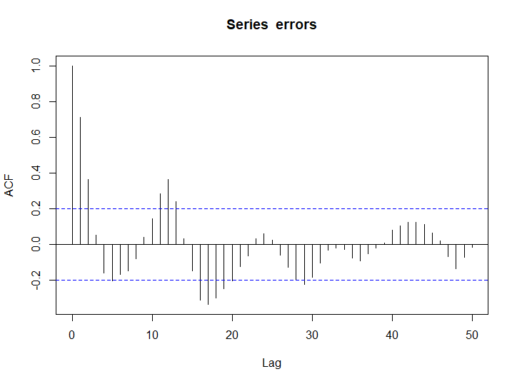

k<-arima(errors, order = c(12,0,0))

k$residuals

Time Series:

Start = 1

End = 96

Frequency = 1

[1] 5.6803258 8.2312042 -8.9204926 7.1287437 -2.3354640 -9.1682133 -13.0539229 -0.8518221 10.9689082 2.6799933 2.9321297

[12] -7.7436964 -10.0622891 10.6590440 -13.2698210 -2.2148638 -7.9821678 0.7559912 -4.8902246 -5.4721714 9.3545631 -4.3783038

[23] -1.9336240 2.8817966 -0.8242335 7.8234719 2.9596753 -1.2224659 16.7551442 -11.8968567 0.1300066 0.8835378 10.6248970

[34] 2.0001200 4.5837259 -0.5755199 1.7639586 8.2692502 -9.7058068 -5.6274310 4.9316217 12.4284413 -11.0964080 10.9182561

[45] -1.1427706 7.7486119 1.1633614 0.5404549 -2.6108949 2.0243434 15.4749246 12.3120294 -1.7639201 -2.4992831 1.0864021

[56] 11.5651742 -7.7626217 -1.9052500 -6.8217231 -5.8622215 -10.3612826 -25.7365416 4.2345061 -14.4862127 -6.1521910 -4.5812553

[67] 5.9815670 -9.4019567 -11.7113042 -4.8631807 -1.5280886 -6.1217284 3.8410888 -9.7488474 1.3682212 1.6447320 -3.0913067

[78] 9.9669819 21.1155642 -6.7675992 0.1057302 -0.8782015 -3.7210233 11.3611743 -2.5051909 -3.3838790 8.8732403 0.7060523

[89] 2.6604385 17.5008169 14.1103759 3.9358711 -11.7545392 -4.9252854 -3.1182653 2.2979237

acf(k$residuals,lag.max = 50)

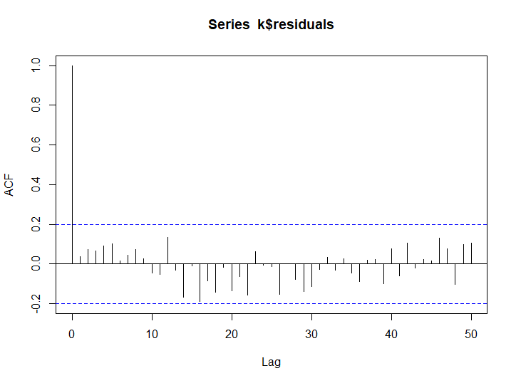

next_12_error<-predict(k, n.ahead = 12)

next_12_error$pred

Time Series:

Start = 97

End = 108

Frequency = 1

[1] -9.8116744 -7.5753663 -4.1153247 -2.3897924 5.4658978 16.2825506 21.9467312 19.7832525 11.7210181 -0.8234086 -8.7635400

[12] -10.9139920

test["forecasted error"]<-next_12_error$pred

test["final_forecast"]<-test$pred_passenger+test$`forecasted error`

Predicting using arima model

pacf(airlines1$Passengers,lag.max = 12)

arima_model<-arima(airlines1$Passengers,order = c(1,1,25))

new_pred<-predict(arima_model,n.ahead = 12)

new_pred$pred

Time Series:

Start = 97

End = 108

Frequency = 1

[1] 334.4454 336.5891 360.6142 358.0714 361.6988 388.8001 409.9607 391.5437 359.9234 330.6560 304.3665 324.2042

Predict sales Prices (Model Based)

library(readxl)

sales<-read_excel(file.choose())

sales1<-sales

sales1["quarter"]<-c(1:42)

for (i in 1:42) {

+ if(i%%4==1)(sales1$quarter[i]="Q1")

+ else if(i%%4==2)(sales1$quarter[i]="Q2")

+ else if(i%%4==3)(sales1$quarter[i]="Q3")

+ else(sales1$quarter[i]="Q4")

+ }

library(dummies)

sales1<-data.frame(sales1,dummy(sales1$quarter))

Warning message:

In model.matrix.default(~x - 1, model.frame(~x - 1), contrasts = FALSE) :

non-list contrasts argument ignored

sales1["t"]<-c(1:42)

sales1["squareT"]<-sales1$t^2

sales1["Log_sales"]<-log(sales1$Sales)

plot(sales1$Sales,type = "o")

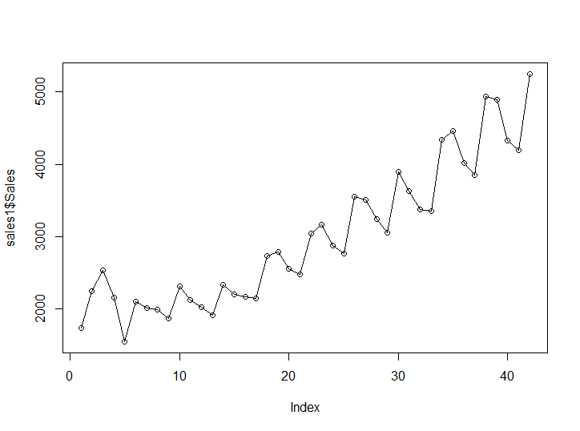

attach(sales1)

The following objects are masked from sales1 (pos = 3):

Log_sales, quarter, Quarter, Sales, sales1Q1, sales1Q2, sales1Q3, sales1Q4, squareT, t

The following objects are masked from sales1 (pos = 4):

Log_sales, quarter, Quarter, Sales, sales1Q1, sales1Q2, sales1Q3, sales1Q4, squareT, t

The following object is masked from trakdata:

t

sales_train<-sales1[1:38,]

sales_test<-sales1[39:42,]

>

linear_model<-lm(Sales~t,data = sales_train)

summary(linear_model)

Call:

lm(formula = Sales ~ t, data = sales_train)

Residuals:

Min 1Q Median 3Q Max

-499.65 -292.80 -17.43 178.54 858.60

Coefficients:

Estimate Std. Error t value Pr(>|t|)

(Intercept) 1490.736 122.247 12.19 2.41e-14 ***

t 68.070 5.464 12.46 1.29e-14 ***

---

Signif. codes: 0 ‘***’ 0.001 ‘**’ 0.01 ‘*’ 0.05 ‘.’ 0.1 ‘ ’ 1

Residual standard error: 369.4 on 36 degrees of freedom

Multiple R-squared: 0.8117, Adjusted R-squared: 0.8065

F-statistic: 155.2 on 1 and 36 DF, p-value: 1.291e-14

pred_linear<-predict(linear_model,sales_test)

rmse_linear<-sqrt(mean((pred_linear-sales_test$Sales)^2))

rmse_linear

[1] 591.5533

>

quadratic_model<-lm(Sales~t+squareT,data = sales_train)

summary(quadratic_model)

Call:

lm(formula = Sales ~ t + squareT, data = sales_train)

Residuals:

Min 1Q Median 3Q Max

-529.93 -226.33 -34.69 258.31 532.73

Coefficients:

Estimate Std. Error t value Pr(>|t|)

(Intercept) 2014.3738 153.6079 13.114 4.54e-15 ***

t -10.4757 18.1635 -0.577 0.568

squareT 2.0140 0.4517 4.459 8.13e-05 ***

---

Signif. codes: 0 ‘***’ 0.001 ‘**’ 0.01 ‘*’ 0.05 ‘.’ 0.1 ‘ ’ 1

Residual standard error: 299.2 on 35 degrees of freedom

Multiple R-squared: 0.8799, Adjusted R-squared: 0.873

F-statistic: 128.2 on 2 and 35 DF, p-value: < 2.2e-16

pred_quadratic<-predict(quadratic_model,sales_test)

rmse_quadratic<-sqrt(mean((pred_quadratic-sales_test$Sales)^2))

rmse_quadratic

[1] 475.5618

>

exponential_model<-lm(Log_sales~t,data = sales_train)

summary(exponential_model)

Call:

lm(formula = Log_sales ~ t, data = sales_train)

Residuals:

Min 1Q Median 3Q Max

-0.21347 -0.10140 -0.01104 0.07500 0.32689

Coefficients:

Estimate Std. Error t value Pr(>|t|)

(Intercept) 7.439351 0.040202 185.05 < 2e-16 ***

t 0.023745 0.001797 13.21 2.24e-15 ***

---

Signif. codes: 0 ‘***’ 0.001 ‘**’ 0.01 ‘*’ 0.05 ‘.’ 0.1 ‘ ’ 1

Residual standard error: 0.1215 on 36 degrees of freedom

Multiple R-squared: 0.8291, Adjusted R-squared: 0.8243

F-statistic: 174.6 on 1 and 36 DF, p-value: 2.241e-15

pred_exponential<-predict(exponential_model,sales_test)

pred_exponential<-exp(pred_exponential)

rmse_exponetial<-sqrt(mean((pred_exponential-sales_test$Sales)^2))

rmse_exponetial

[1] 466.248

>

additive_model<-lm(Sales~sales1Q1+sales1Q2+sales1Q3+sales1Q4,data = sales_train)

summary(additive_model)

Call:

lm(formula = Sales ~ sales1Q1 + sales1Q2 + sales1Q3 + sales1Q4,

data = sales_train)

Residuals:

Min 1Q Median 3Q Max

-1045.6 -712.4 -151.3 580.0 1786.0

Coefficients: (1 not defined because of singularities)

Estimate Std. Error t value Pr(>|t|)

(Intercept) 2712.9 277.5 9.777 2.07e-11 ***

sales1Q1 -240.4 382.5 -0.628 0.534

sales1Q2 437.1 382.5 1.143 0.261

sales1Q3 225.5 392.4 0.575 0.569

sales1Q4 NA NA NA NA

---

Signif. codes: 0 ‘***’ 0.001 ‘**’ 0.01 ‘*’ 0.05 ‘.’ 0.1 ‘ ’ 1

Residual standard error: 832.4 on 34 degrees of freedom

Multiple R-squared: 0.09682, Adjusted R-squared: 0.01712

F-statistic: 1.215 on 3 and 34 DF, p-value: 0.3192

pred_additive<-predict(additive_model,sales_test)

Warning message:

In predict.lm(additive_model, sales_test) :

prediction from a rank-deficient fit may be misleading

rmse_additive<-sqrt(mean((pred_additive-sales_test$Sales)^2))

rmse_additive

[1] 1860.024

>

additive_quadratic_model<-lm(Sales~t+squareT+sales1Q1+sales1Q2+sales1Q3+sales1Q4,data = sales_train)

summary(additive_quadratic_model)

Call:

lm(formula = Sales ~ t + squareT + sales1Q1 + sales1Q2 + sales1Q3 +

sales1Q4, data = sales_train)

Residuals:

Min 1Q Median 3Q Max

-283.43 -132.23 33.95 113.50 339.45

Coefficients: (1 not defined because of singularities)

Estimate Std. Error t value Pr(>|t|)

(Intercept) 1919.5127 99.1228 19.365 < 2e-16 ***

t -12.2698 9.9389 -1.235 0.225996

squareT 2.0503 0.2472 8.292 1.79e-09 ***

sales1Q1 -224.6248 75.0193 -2.994 0.005272 **

sales1Q2 385.1285 74.9807 5.136 1.34e-05 ***

sales1Q3 293.1949 76.6975 3.823 0.000575 ***

sales1Q4 NA NA NA NA

---

Signif. codes: 0 ‘***’ 0.001 ‘**’ 0.01 ‘*’ 0.05 ‘.’ 0.1 ‘ ’ 1

Residual standard error: 162.6 on 32 degrees of freedom

Multiple R-squared: 0.9676, Adjusted R-squared: 0.9625

F-statistic: 190.9 on 5 and 32 DF, p-value: < 2.2e-16

pred_additive_quadratic<-predict(additive_quadratic_model,sales_test)

Warning message:

In predict.lm(additive_quadratic_model, sales_test) :

prediction from a rank-deficient fit may be misleading

rmse_additive_quadratic<-sqrt(mean((pred_additive_quadratic-sales_test$Sales)^2))

rmse_additive_quadratic

[1] 301.738

>

multi_model<-lm(Log_sales ~sales1Q1+sales1Q2+sales1Q3+sales1Q4,data = sales_train)

summary(multi_model)

Call:

lm(formula = Log_sales ~ sales1Q1 + sales1Q2 + sales1Q3 + sales1Q4,

data = sales_train)

Residuals:

Min 1Q Median 3Q Max

-0.42608 -0.25715 -0.02373 0.23630 0.49157

Coefficients: (1 not defined because of singularities)

Estimate Std. Error t value Pr(>|t|)

(Intercept) 7.87651 0.09539 82.574 <2e-16 ***

sales1Q1 -0.10583 0.13148 -0.805 0.426

sales1Q2 0.13623 0.13148 1.036 0.307

sales1Q3 0.07542 0.13490 0.559 0.580

sales1Q4 NA NA NA NA

---

Signif. codes: 0 ‘***’ 0.001 ‘**’ 0.01 ‘*’ 0.05 ‘.’ 0.1 ‘ ’ 1

Residual standard error: 0.2862 on 34 degrees of freedom

Multiple R-squared: 0.1041, Adjusted R-squared: 0.025

F-statistic: 1.316 on 3 and 34 DF, p-value: 0.2851

pred_multi<-predict(multi_model,sales_test)

Warning message:

In predict.lm(multi_model, sales_test) :

prediction from a rank-deficient fit may be misleading

pred_multi<-exp(pred_multi)

rmse_multi<-sqrt(mean((pred_multi-sales_test$Sales)^2))

rmse_multi

[1] 1963.39

>

rmse<-c(rmse_linear,rmse_quadratic,rmse_exponetial,rmse_additive,rmse_additive_quadratic,rmse_multi)

rmse

[1] 591.5533 475.5618 466.2480 1860.0238 301.7380 1963.3896

>

write.csv(sales1,file = "sales_next.csv")

>

final_model<-lm(Sales~t+squareT+sales1Q1+sales1Q2+sales1Q3+sales1Q4,data = sales1)

resid<-final_model$residuals

acf(resid,lag.max = 42)

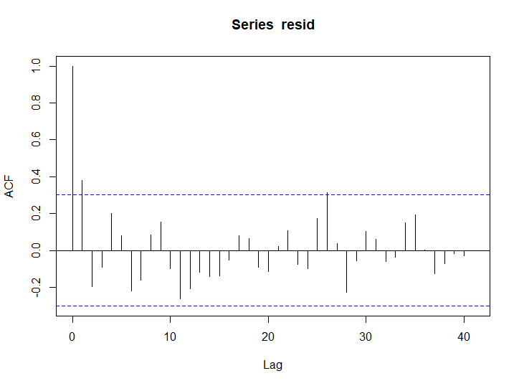

k<-arima(resid,order = c(2,0,0))

acf(k$residuals,lag.max = 42)

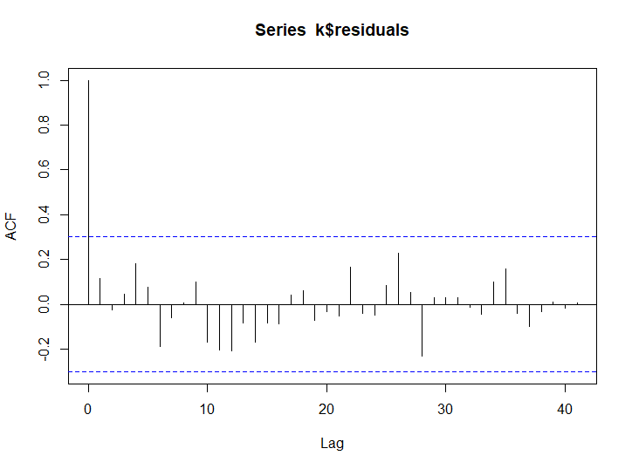

new_error<-predict(k,n.ahead = 4)

new_error1<-new_error$pred

>

sales_next<-read.csv(file.choose())

pred_sales<-data.frame(sales_next,predict(final_model,sales_next))

Warning message:

In predict.lm(final_model, sales_next) :

prediction from a rank-deficient fit may be misleading

pred_sales<-data.frame(pred_sales,new_error1)

pred_sales["pred_sales_final"]<-(pred_sales$predict.final_model..sales_next.+pred_sales$new_error1)

sales_model<-append(sales1$Sales,pred_sales$pred_sales_final)

plot(sales_model,type = "o")

